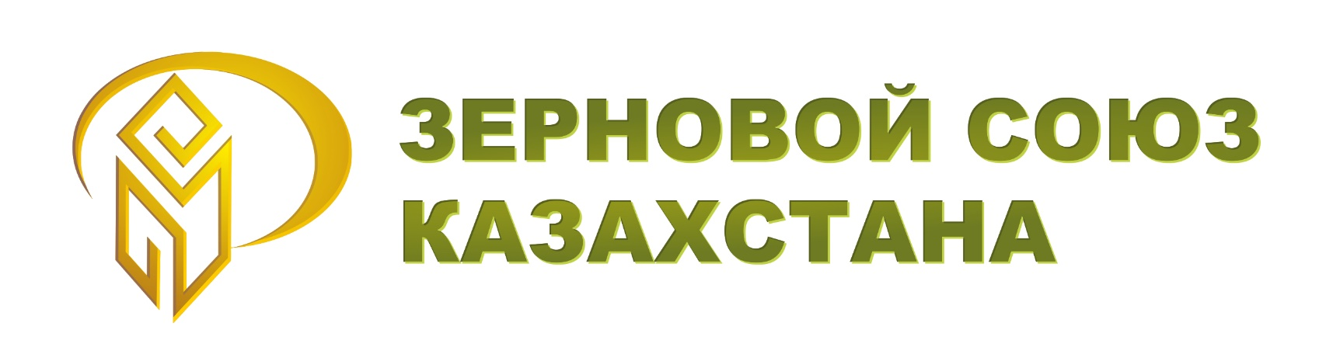

INFORMATION for potential participants of the ALE "Grain Union of Kazakhstan"

- General information about the Grain Union

- Date of establishment, mission, goals and objectives
The ALE "The Grain Union of Kazakhstan" was founded on November 2, 1995.
The mission of the Union is to create favorable conditions for the sustainable development of the grain market in Kazakhstan.
The purpose of the Union is to unite enterprises and organizations of the grain market to coordinate their activities, submission and protections of the common interests, and also promote the sustainable development of the grain industry.
Main tasks:
- The formation of effective interaction with government agencies, commercial and non-profit organizations to represent and protect the common legal interests of the Union members;
- Improvement of the legislation of the Republic of Kazakhstan, regulating organizations activities of the grain industry, as well as targeted programs and projects in the field of development and support of the grain industry;
- Participation in the creation of favorable conditions for the functioning and development of organizations of the grain industry;
- Cooperation with the subjects of organized trade (commodity exchanges, brokers, dealers);
- Informational and consulting support for the grain industry organizations, development of cooperation with kazakh and foreign information agencies and consulting companies;
- Assistance in training qualified personnel for the Union members.

- Composition of the Grain Union (sectors, participants)
The participants of the Grain Union are the largest producers of grain, oilseeds and legumes in Kazakhstan; leading exporters of crop products; grain-receiving enterprises and grain elevators; inspection companies; official distributors and dealers of pesticides and agricultural equipment; transport and forwarding companies, information and analytical publications.

- Accreditation and cooperation with the National Chamber of Entrepreneurs of the Republic of Kazakhstan "Atameken"
The ALE "Grain Union of Kazakhstan" is accredited by the National Chamber of Entrepreneurs of the Republic of Kazakhstan "Atameken" (Accreditation Certificate No. 000049) and is a member of the Committee of the Agro-industrial industry of the Presidium of NCE RK "Atameken"

- Accreditation in the Ministry of Agriculture
The Chairman of the Grain Union is a member of the Council on Agrarian Policy under the Ministry of Agriculture of the Republic of Kazakhstan.

- Participation in other consultative and advisory agencies.
- The Chairman of the Grain Union is a member of the Commission for the presidential “Altyn Sapa” prize award;
- The Grain Union representatives take part in working groups which are set up by the state agencies and companies on matters affecting the interests of the Union members.
- Regular events of the Grain Union
Organization and support:
- Grain Union organizes quarterly meetings on the problematic issues of the grain market;
- International Conference "Kazakh Durum Days" ("Days of Kazakh durum wheat");
- International Conference "KAZGRAIN"
- International Conference "KAZOIL"
Участие с докладом:
- International Conference "Durum Days" (Days of Durum Wheat) in Foggia, Italy
1. About participation in the Grain Union
The main provisions of the Charter to participate in Grain Union
- Union participants can become any commercial and non-commercial organizations whose activities are not contrary to the purpose of the establishment and the subject of the Union’s activities, and are carried out in the agro-industrial complex, including the production, storage, processing, sale, quality expertise of grain, leguminous plants and oilseeds, the supply of agricultural machinery and chemicals, transport and logistics, information support, as well as other areas of activity.
- Participation in the Union may be suspended, terminated voluntarily or on the basis of the general meeting decision by the Union members.
- Reasons to remove from the Union membership are:
a) Violation of the Union’s Charter rights
b) Disclosure of official or commercial secrets as well as other confidential information
c) Causing significant detriment or committing deliberate acts which discredit the Union;
d) Non-payment of membership fees within one year;
e) Failure to comply with decisions of the Union
3) The order of entry into the grain union
1. Preparation of a written application by one of the active participants or staff of the Grain Union;
2. Filling out the application form and the candidate's application for entry into the Grain Union
3. The decision-making process is accepted by the participants of the Grain Union at the general meeting
4. Preparation of an extract from the minutes of the general meeting of Grain Union Participants
5. Conclusion of a treaty on participation in the Grain Union
4) About the bodies of the Grain Union
a) The General meeting is the supreme governing body of the Union members (their representatives). Only one representative with one vote is allowed from each member of the Union.
b) The governing body of the Union is the Chairman, which is elected by the General Assembly of the members of the Union.
c) The Union has a Council, which is its governing body, headed by the Chairman of the Union. The Council of the Union is composed of at least 5 people and consists of the Chairman of the Union, the Executive Director and the first heads of legal entities - members of the Union.
d) The Executive Committee is the executive body of the Union, which carries out the current management of the Union, is accountable to the General Assembly of the Union members, the Chairman of the Union, and the Council of the Union and organizes the implementation of their decisions. The Executive Committee is headed by an Executive Director.
e) The Audit Commission is a supervisory body (collegial), whose members are elected by the General Meeting of the Union members for a period of 2 (two) years. The audit commission is formed in an amount of at least 3 (three) people.

5) About the consultative and advisory bodies of the Grain Union
To carry out expert-analytical work under the Executive Committee of the Union, the following permanent expert groups have been created, supervised by the relevant members of the Council of the Union
- By specialization "Grain production"
- By specialization "Storage of grain"
- By specialization " Agricultural machinery "
- By specialization "Agricultural chemistry"
- By specialization "Land Relations"
- By specialization "Trading"
- By specialization "Transport and Logistics"
- By specialization "Quality Control"
- By specialization "Lending, leasing and insurance"
- By specialization "Taxation and Accounting"
- By specialization "Commercial Law"
6) About the rights and obligations of the Grain Union participant
- The right to be included in the governing bodies of the Grain Union;
- The right to initiate proposals for consideration by the bodies of the Grain Union;
- The right to participate in the consultative and advisory bodies at the National Chamber of entrepreneurs "Atameken", state bodies and state companies;
- The right to protection of legitimate interests in relations with state bodies and state companies
- The right to receive priority information of the Grain Union
- The right to receive preferential tariffs for services rendered by the Grain Union and its partners
- Obligation to comply with the Charter and internal documents of the Grain Union
- Responsibility to facilitate the work of the consultative and advisory bodies of the Grain Union
- Obligation to support and promote the business reputation of the Grain Union

